

People's Democratic Republic of Algeria
Ministry of Higher Education and Scientific Research
University of Science and Technology Houari Boumediene

Faculty of Computer Science
Department of Artificial Intelligence and Data Science

Bachelor’s Thesis

Field: Computer Science
Specialization: Academic Computer Science

Thème

Geospatial Segmentation Based on Infrastructure and Building Types (Case Study: City of Algiers)

Proposed by:
Mohamed Amine BENATMANE

Presented by:
TAOUINT Abderahman
BENBOUTELDJA Akram
OUAHIB Elyes
BOUCHIRIFI Nassim
Group : ACAD042/2024

Committee Members:
M.BEHLOUL Djilali
Mme.DERBAL Khalissa
Content
General Introduction 4
Chapter 1: State of the Art / Existing Study 6
1.1 Introduction and Problem Statement 6
1.2 About the Telecom Provider DJEZZY 6
1.3 Current Organization of Operational Monitoring 7
1.4 Other Use Cases for Geospatial Data 7
1.5 Issues in Technical Monitoring 7
1.5.1 Concrete Consequences for the Company 7
1.5.2 Challenges for End Users 8
1.6 Existing Methods for Data Analysis and Mapping 8
1.6.1 Classical Supervision 8
1.6.2 Geographic Information Systems (GIS 8
1.7 Proposed Solution 8
1.7.1 Objectives of the Solution 8
1.7.2 General System Description 8
1.8 Machine Learning and Data Processing 9
1.9 Why an Intelligent Mapping Solution? 9
Chapter Conclusion 9
Chapter 2: Analysis and Design of the Solution 10
2.1 Raster Data Processing 10
2.1.1 Critical Importance of Raster Data Quality for Spatial Processing 10
2.1.2 Sources and Nature of Data 11
2.2 Analysis and Segmentation Pipeline 11
2.3 Cartographic Visualization 14
2.3.1 Tool Selection: Folium 14
2.3.2 Structure of the Final Map 14
2.3.3 Export and Integration 14
2.4 Automation and Pipeline Modularity 14
2.5 Global Pipeline Architecture 15
15
2.6 Technical Constraints Encountered 15
Chapter Conclusion 16
Chapter 3: Practical Implementation and Results Analysis 16
3.1 Geospatial Processing and Analysis Pipeline 16
3.2 Key Tools and Technologies 16
3.2.1 GIS Software and External Tools 17
3.2.2 Data Sources 17
3.2.3 Python Libraries 18
3.3 Geospatial Processing Pipeline (Python) 18
3.3.1 Data Loading and Preparation 18
3.3.3 Clustering with KMeans (MiniBatch) 19
3.3.4 Label Assignment 19
3.3.5 Interactive Cartographic Visualization 19
3.4 Technical Constraints Encountered 20
3.4.1 Coordinate Reference System (CRS) Issues 20
3.4.2 Spatial Mask Reconstruction 20
3.4.3 Cluster Number Stability (Elbow Method) 20
3.4.4 HTML Map Size 20
3.5 Results Analysis 20
3.6 Integration into a Web Platform 21
3.7 Conclusion 22
Conclusion and Perspectives 22
Conclusion 22
Perspectives 23
Bibliographic References 24
Annexes 26

Figures Table
Figure 1: Elbow methode result
Figure 2: Diagram of the Geospatial Processing and Visualization Pipeline
Figure 3: Final clustering result on the interactive map
Figure 4: Example of final display (case: population)

General Introduction

We are living in an era of profound digital transformation, where information and communication technologies play a key role in the evolution of businesses. These technologies enable process optimization, automation of repetitive tasks, and faster decision-making through intelligent data exploitation. Among the sectors most impacted by these advancements, telecommunications hold a strategic position.
In Algeria, Djezzy is one of the leading mobile operators. Faced with a constant increase in users, data demand, and network complexity (3G, 4G, and upcoming 5G), Djezzy faces major challenges: ensuring optimal nationwide coverage, quickly identifying underserved areas, anticipating congestion, and optimizing infrastructure deployment.
Traditionally, these operations require human intervention, on-site surveys, and manual network data analysis. This process is time-consuming, costly, and not easily scalable. Moreover, current tools offer limited visibility into critical network areas, particularly in densely populated regions or areas with complex topography.
This context frames our end-of-cycle project, developed in collaboration with Djezzy. It aims to propose an intelligent, automated solution for spatial analysis of the mobile network, leveraging geospatial data provided as raster layers (.tif files). Our application identifies strategic zones (highly populated, congested, or sensitive), clusters them based on their profile, and displays them clearly and interactively on a dynamic map.
This solution relies on a rigorous methodological sequence: raster data processing and cleaning, automatic detection of significant zones, clustering into homogeneous groups, and geographic visualization using web technologies. The approach is automated, interactive, and scalable. It targets network engineers and Djezzy decision-makers seeking a decision-support tool to visualize critical network insights within seconds.
The originality of our project lies in integrating automated spatial analysis with a modern cartographic interface. It not only locates areas of interest but also enables comparison, trend tracking, and strategic infrastructure planning.

The report is structured as follows:
Introduction —Presents the project context, challenges in mobile network coverage analysis, and objectives for developing an intelligent, interactive spatial analysis tool.
Chapter 1: State of the Art and Existing Study — Reviews Djezzy’s current network management practices, tools, challenges, and existing approaches in spatial analysis and mapping.
Chapter 2: Proposed Solution — Details the solution designed to address identified needs. Highlights its functionalities, technological choices, and expected contributions to automation, network visibility, and decision-making.
Chapter 3: Practical Implementation and Results Analysis — Describes the development environment, implementation steps, and initial results using provided data.
Conclusion and Perspectives — Summarizes the project’s contributions, limitations, and proposes improvements for real-world deployment.

Chapter 1: State of the Art / Existing Study

1.1 Introduction and Problem Statement
Before proposing a technical solution, it is essential to understand Djezzy’s operational context and the constraints specific to analyzing mobile network activity across Algeria. With rising subscribers, diverse geographic coverage (urban, rural, remote), and rapid technological evolution (transition to 4G/5G), the need for intelligent tools to evaluate territorial performance has become strategic.
Despite classical supervision tools, identifying underserved or high-demand zones remains challenging, slow, and labor-intensive. Limited visualization and partial manual analysis hinder field team responsiveness and strategic decision-making.
In summary, the problem addressed by our project is:
“How to automatically identify, cluster, and visualize critical mobile network zones to enable better decision-making and continuous service quality optimization?”

1.2 About the Telecom Provider DJEZZY
The Algerian telecommunications operator Djezzy, founded in July 2001, is a leader in Algeria’s mobile sector. With over 15 million subscribers as of September 2023, Djezzy offers a full range of services, including prepaid, postpaid, data, value-added services, and SUT. Djezzy has consistently distinguished itself through innovation and service quality, aiming to become a leading technological player in Algeria.
Since July 2022, a major shift occurred with VEON’s transfer of nearly all shares to the FNI (National Investment Fund). As a Public Economic Enterprise, Djezzy is now 96.57% owned by the FNI, which plays a significant role in the country’s socio-economic development. The company aims to expand its commercial network nationwide, particularly in the southern regions, by opening stores in ten new provinces.
Djezzy has achieved significant connectivity milestones, covering 95% of Algeria’s population and successfully deploying 3G and 4G services across 58 provinces. These achievements, including 2G, 3G, and 4G licenses, reflect its commitment to technological expansion.
Djezzy’s ambition extends further. As a public enterprise, it seeks to become a major technological actor in Algeria, fostering connectivity and contributing to national digitalization. With its experience and leadership, Djezzy strives to shape Algeria’s technological future by offering innovative solutions and ensuring quality communication access nationwide.

1.3 Current Organization of Operational Monitoring

Technical monitoring at Djezzy relies on internal software tools, analytical dashboards, and human intervention. Data is collected from antenna sensors, system logs, and customer feedback.
However, spatial analysis of this data remains fragmented. Technical teams use static maps or complex tools to locate low-signal zones, congestion, or incidents. Processing is partially automated but still requires expert interpretation and decision-making.

1.4 Other Use Cases for Geospatial Data
Beyond coverage analysis, geospatial mechanisms can apply to:
- Infrastructure deployment optimization
- Congestion detection
- Geographic marketing targeting
- Technical intervention planning
- Customer complaint tracking
- Predictive analysis

1.5 Issues in Technical Monitoring
Despite efforts, several challenges persist:
- Lack of Intuitive Visualization: Current tools are technical and non-cartographic.
- Limited Automation: Critical zone detection relies on manual thresholds or reports.
- High Reaction Time: Precise problem localization is time-consuming.
- No Clustering of Similar Zones: Complicates intervention prioritization.

1.5.1 Concrete Consequences for the Company
- Operational Inefficiency: Difficulty acting swiftly on critical zones.
- Increased Workload for Technical Teams: Manual analysis and constant monitoring.
- Risk of Poor Antenna Deployment Planning.
- Customer Dissatisfaction due to slow response or lack of signal.

1.5.2 Challenges for End Users
- Uneven service quality
- Lack of outage information
- No real-time network status visibility

1.6 Existing Methods for Data Analysis and Mapping

1.6.1 Classical Supervision
Internal software displays indicators via tables or static maps. Limited automated spatial detection.

1.6.2 Geographic Information Systems (GIS)
Tools like QGIS visualize infrastructure but remain manual and technical, unsuitable for dynamic, large-scale analysis.

1.7 Proposed Solution
To address these limitations, we propose an intelligent mapping solution capable of:
- Processing geospatial raster data using machine learning
- Identifying densely populated or underserved zones
- Clustering zones by technical profile
- Displaying them on an interactive, customizable map
This solution simplifies technical team workflows and provides a clear, updated network overview for maintenance and expansion planning.

1.7.1 Objectives of the Solution
- Automate critical zone identification
- Offer dynamic mapping
- Enable rapid strategic data interpretation
- Strengthen decision-making for interventions and deployments

1.7.2 General System Description
Our solution comprises integrated steps in an efficient pipeline:
- Input: Raster layers with multiple information types
- Automated Processing: Detection of relevant zones, intelligent clustering
- Output: Interactive map with layers accessible to any agent

1.8 Machine Learning and Data Processing
Machine learning (ML), a subfield of artificial intelligence, enables systems to learn from data without explicit programming. ML algorithms identify hidden patterns, complex relationships, and automate decisions from large datasets.
Data preprocessing is crucial: cleaning, structuring, and preparing data ensures quality. ML algorithms then extract value through predictions, segmentation, or classification.
Unsupervised clustering groups data with similar features without manual intervention, making ML ideal for large, heterogeneous datasets. It becomes a powerful tool for decision support, process automation, and strategic insights.

1.9 Why an Intelligent Mapping Solution?
From the outset, our project aimed to innovate by automating geospatial analysis for Djezzy, enabling technical and strategic decision-making at scale.
Traditional analysis, reliant on technical reports or static GIS tools, is time-consuming and non-interactive. Our solution modernizes supervision tools by integrating artificial intelligence (via unsupervised clustering) and web technologies (via Folium) into spatial analysis. It enables:
- Automatic critical zone identification
- Interactive visualization within seconds
- Reduced manual workload for GIS/data teams
In summary, it is a hybrid tool combining technical analysis and strategic visualization, enhancing Djezzy’s ability to manage its territory and anticipate network needs.

Chapter Conclusion
This chapter outlined the project’s context, highlighting Djezzy’s challenges in network analysis and the limitations of existing approaches. By exploring current methods and identifying Djezzy’s needs, we defined an innovative, reusable solution. The next chapter details this solution’s architecture, functionalities, and contributions.

Chapter 2: Analysis and Design of the Solution

In this chapter, we detail the approach adopted to design and develop our intelligent geospatial analysis solution within the telecommunications operator Djezzy. The main objective is to provide a tool capable of extracting, segmenting, and visualizing critical areas based on complex raster data (such as population density, infrastructure, etc.), while ensuring robust performance and high readability.
The success of this project relies on two fundamental pillars: the quality of the input data (raster format, georeferenced) and the accuracy of the methodological approach for spatial processing and automatic segmentation. The solution combines a range of tools and techniques from data science, geomatics, and unsupervised machine learning.

2.1 Raster Data Processing

2.1.1 Critical Importance of Raster Data Quality for Spatial Processing
In any project based on geospatial data analysis, the quality of the source files plays a decisive role. The effectiveness of the analysis pipeline directly depends on the precision, resolution, and consistency of the raster layers used. The slightest error in geographic metadata, spatial projection, or missing values can lead to misalignments, incorrect results, or complete failure of certain processing stages.
In the context of our project—an automated analysis and intelligent visualization solution designed for a telecom operator like Djezzy—this issue is even more critical. Indeed, the geographic segmentation of a territory and the interpretation of areas of interest can only be relevant if the input data is reliable and well-aligned.

This requirement is all the more important because:
• The raster files must be spatially compatible (same coordinates, same resolution);
• “NoData” values must be correctly managed to avoid bias;
• The quality of the data directly affects the validity of the generated clusters and their cartographic readability.

The main risks associated with poor-quality raster data include:
• Incorrect groupings (misaligned zones or faulty masks);
• Misinterpretation of indicators (density, land use);
• Unreadable or inaccurate visualizations;
• Excessively long or failed processing due to noisy or corrupted data.

2.1.2 Sources and Nature of Data
The data used in this project comes from two open, reliable, and regularly updated sources:
• OpenStreetMap (OSM): Used to extract vector data related to buildings, roads, and infrastructure. This data was used to generate a raster layer estimating construction density per unit area.
• Global Human Settlement Layer (GHSL) – https://human-settlement.emergency.copernicus.eu/: This platform, developed by the Joint Research Centre (JRC) of the European Commission as part of the Copernicus program, provides high-resolution raster layers representing land use and human presence distribution. It is internationally recognized for the quality of its geospatial products derived from satellite imagery.
• GADM – Database of Global Administrative Areas – https://gadm.org/: GADM is a cartographic database that provides detailed administrative boundaries for all countries in the world. It offers files in shapefile or GeoJSON format, commonly used in geomatics and spatial analyses. GADM is particularly useful for linking statistical or geographic data to administrative entities (countries, regions, wilayas, municipalities, etc.).
To tailor these datasets to our study area—the Wilaya of Algiers—we used the QGIS software to:
• Perform spatial clipping based on the geographic extent of Algiers;
• Convert vector data to raster format when necessary;
• Harmonize the coordinate reference systems (CRS) across all layers.
The combined use of these data sources, coupled with meticulous preparation in QGIS, resulted in a coherent, targeted dataset that could be directly processed by our analysis pipeline.

2.2 Analysis and Segmentation Pipeline

This section outlines the various steps involved in analyzing and processing raster data with the aim of producing a segmented and interpretable map. The pipeline is based on a combination of unsupervised clustering techniques applied to geospatial data extracted from raster layers. It proceeds through three main stages: an initial filtering to extract dense areas, intelligent grouping through clustering, and spatial reconstruction for display.

2.2.1 Coordinate Reference Systems (CRS)
In the context of this project, all geospatial data was reprojected into the EPSG:4326 coordinate reference system, which corresponds to the WGS 84 (World Geodetic System 1984) standard. This system, based on geographic coordinates expressed in decimal degrees (longitude, latitude), is widely recognized as the international standard for georeferencing. It is used in most GIS tools (such as QGIS), Python libraries (Rasterio, Folium), and web mapping systems (Leaflet.js). The use of EPSG:4326 ensures full interoperability between the different data sources used in this project (GHSL, OpenStreetMap, GADM), while guaranteeing proper layer alignment in the final visualization. The reprojection was carried out using QGIS for the initial processing and then automated in the Python pipeline using Rasterio, thus ensuring spatial consistency throughout the entire workflow.
2.2.2 Spatial Filtering with HDBSCAN
Spatial filtering is the first critical step of the pipeline. Its objective is to isolate regions that show a high density of relevant data (e.g., high population and building concentration). To achieve this, we use the HDBSCAN algorithm (Hierarchical Density-Based Spatial Clustering of Applications with Noise), which is particularly well-suited for noisy data and uneven density structures.
Unlike KMeans, HDBSCAN does not require specifying the number of clusters in advance. It relies on local density to identify homogeneous zones and automatically removes isolated or insignificant points. This allows us to obtain a spatial mask that represents only the areas of interest while drastically reducing noise in the data.
The main advantages of HDBSCAN in our context are:
• Automatic detection of the potential number of clusters (unsupervised)
• Natural elimination of dispersed pixels (noise)
• Adaptability to variable data density (urban vs. peri-urban zones)
The resulting mask is a preliminary binary map in which only pixels belonging to dense zones are retained. This subset then becomes the basis for the next clustering step.
2.2.3 Clustering with MiniBatchKMeans
After isolating the relevant zones, we apply a second level of grouping: clustering using MiniBatchKMeans. This is a faster and more scalable variant of the standard KMeans algorithm, better suited for large datasets.
The goal here is to group the filtered pixels based on feature similarity (population density, building density) to form coherent and homogeneous zones. These groups are referred to as "clusters" and may represent different types of areas: high-density residential zones, industrial zones, peri-urban neighborhoods, etc.
The number of clusters, K, is empirically determined using the elbow method. This technique involves plotting intra-cluster inertia (the sum of distances from points to their centroids) against the number of clusters. The inflection point on the curve indicates a good trade-off between group compactness and model complexity. In our case, the elbow was clearly observed at K = 4, which provided a suitable balance between group coherence and cartographic readability. These four clusters reflect distinct, interpretable zone profiles that are useful for decision-making. This choice was validated empirically through a stable and meaningfully segmented final visualization.
This step results in a cluster label being assigned to each filtered pixel.

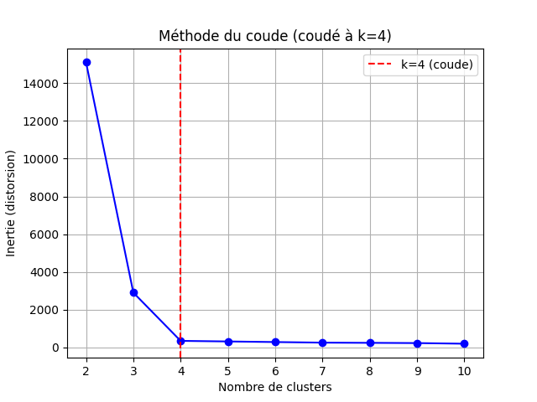
Figure1 : Elbow methode result

2.2.4 Label Assignment and Geographic Reconstruction
Once the clusters are generated, each pixel that passed the HDBSCAN filtering stage is assigned a numerical label (0, 1, 2, ...). These labels are then reintegrated into a 2D matrix with the same dimensions as the original raster (representing population, buildings, or other key infrastructure).
All filtered pixels receive a cluster identifier; the others are marked as -1 or left blank. This enables the reconstruction of a thematic map, where each colored region corresponds to a specific cluster.
The segmented matrix is then converted into an RGB image and overlaid on a base map (using Folium) to provide a clear geographic visualization of the results.

2.3 Cartographic Visualization

2.3.1 Tool Selection: Folium
Chosen for compatibility with Leaflet.js, Folium supports:
- Raster layer display
- GeoJSON vector layers
- Custom legends (via Branca)

2.3.2 Structure of the Final Map
Interactive layers include:
- Color-coded clusters representing urban segmentation
- Filtered layers of key infrastructures (e.g., hospitals, commercial centers, etc.)
- Population density visualization
- Building density visualization
- Explanatory legends for each thematic layer

2.3.3 Export and Integration
Maps are exported as HTML for web integration.

2.4 Automation and Pipeline Modularity
The entire processing workflow is based on an automated pipeline designed to be modular, reusable, and easy to maintain. Each step—from data import to the final map export—is encapsulated in an independent block, which simplifies testing, modification, or replacement of components without affecting the rest of the process.
This architectural choice offers several major advantages:
• Significant reduction in processing time
Thanks to automation, complex operations (data cleaning, spatial filtering, clustering, map generation) can be completed in just a few minutes, compared to several hours when performed manually. This also makes it possible to repeat the analysis regularly as data is updated, without additional workload.
• Full replicability across other geographic or thematic areas
The pipeline can be applied to other cities, wilayas, or countries without major adjustments. Simply replacing the input datasets (population/infrastructure rasters) allows for local segmentation using the same analysis logic. This portability makes it particularly valuable for a national operator like Djezzy.
• Simple integration into a production environment
The results are designed to be directly usable, in the form of an interactive HTML map. The pipeline can be integrated into an internal website, a decision-making dashboard, or a cloud infrastructure, without requiring traditional GIS tools. This facilitates adoption by non-technical teams.

2.5 Global Pipeline Architecture
- Raster import
- Data cleaning/valid pixel extraction
- Spatial filtering (HDBSCAN)
- KMeans clustering
- 2D mask reconstruction
- Interactive map display (Folium)

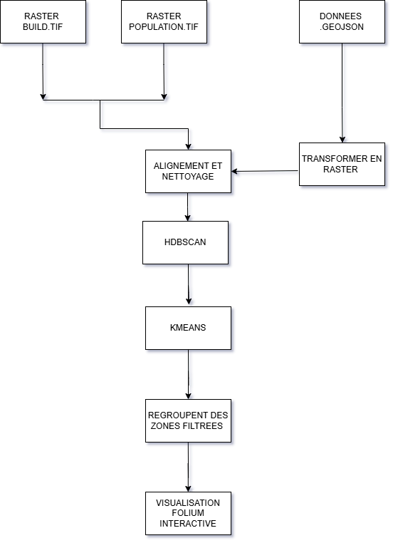

Figure 2: Diagram of the Geospatial Processing and Visualization Pipeline

2.6 Technical Constraints Encountered
- Managing differing CRS and raster sizes
- Spatial mask reconstruction (HDBSCAN output to 2D grid)
- Stable cluster count determination (Elbow Method)
- Map readability and HTML export size

Chapter Conclusion
This chapter detailed our design approach, from raster processing to interactive visualization. The modular system meets Djezzy’s needs for intelligent zone analysis. The next chapter covers implementation, testing, and results.

Chapter 3: Practical Implementation and Results Analysis

3.1 Geospatial Processing and Analysis Pipeline
The core of our project is based on a geospatial analysis pipeline designed to process raster and vector layers and produce intelligent segmentations of the urban territory. This pipeline, fully implemented in Python, combines several tools for spatial processing, unsupervised learning, and interactive visualization. Its main purpose is to identify, classify, and visually represent the different areas of the Wilaya of Algiers according to their population and infrastructure density.
Through a series of processes—including reprojection, data cleaning, spatial filtering with HDBSCAN, and clustering with KMeans—the pipeline allows us to transform raw data from GHSL and OpenStreetMap into a clear, usable, and strategically valuable map for a telecommunications operator like Djezzy. This modular system not only ensures great flexibility in adjusting parameters (number of clusters, density thresholds, etc.) but also provides the capacity to integrate new analysis layers (such as roads, antennas, commercial zones) in future extensions.

3.2 Key Tools and Technologies
The implementation of our geospatial analysis project for the telecom operator Djezzy relies on a coherent set of tools, programming languages, and technologies. These choices were guided by criteria such as performance, compatibility with geographic data, and the ability to efficiently process large volumes of raster data.
Python was used as the primary foundation for developing the processing pipeline, as it offers a wide range of libraries specialized in geospatial data manipulation, clustering, and visualization. It is also widely recognized for its simplicity, flexibility, and strong developer community.
In parallel, web technologies such as HTML and CSS were used to integrate the interactive map into a web interface. This combination allows us to deliver a solution that is not only powerful in terms of analytics, but also user-friendly and accessible for end users.

3.2.1 GIS Software and External Tools
Software / Tool | Function | Specific Role
QGIS | GIS / Preprocessing | Reprojection, spatial clipping, rasterization of OSM layers.
Visual Studio Code (VS Code) | Code editor | Python development, project file management.
GitHub | Versioning and collaboration | Code backup, version tracking, potential collaboration
Photoshop | Graphic editing | Cleaning or annotating images/screenshots used in the report or the map

3.2.2 Data Sources
Source | Type | Description
Human Settlement Layer | Raster | Population density, high-resolution land use.
Database of Global Administrative Areas | Vector(converted to raster) | Algiers boundries
OpenStreetMap (OSM) | Vector(converted to raster) | Infrastructure (buildings, roads, points of interest).

3.2.3 Python Libraries

Library | Main Use | Details
NumPy / Pandas | Data manipulation | Raster matrices, statistics, tabular merging.
Rasterio | Raster geospatial processing | Reprojection, alignment, reading/writing .tif files.
scikit-learn | Clustering | Fast implementation of MiniBatchKMeans.
HDBSCAN | Unsupervised clustering | Automatic detection of dense zones, noise removal.
Matplotlib | Analytical visualization | Elbow method, control plots.
Folium | Interactive visualization | Generating interactive HTML maps.
Branca | Folium visual elements | Creating legends, color bars, tooltips, and other HTML elements.
Joblib | Optimization | Saving/loading clustering models.

3.3 Geospatial Processing Pipeline (Python)

3.3.1 Data Loading and Preparation
The rasters used in this project come primarily from two open data sources: the Global Human Settlement Layer (GHSL), for population and built-up density data, and OpenStreetMap (OSM), for vector data related to buildings, roads, and urban services. These data are first imported into QGIS for essential preprocessing before being used in Python. This preprocessing includes:
• Standardizing the projection system to EPSG:4326 (WGS 84) to ensure compatibility with web mapping tools and Python libraries,
• Harmonizing spatial resolution across the layers,
• Cleaning null values, removing geographic noise, and excluding areas outside the study perimeter.
In addition, Algeria’s administrative boundaries (wilayas and municipalities), taken from the GADM database, were used as a spatial mask to precisely clip the raster layers to the Wilaya of Algiers, the focus of our study. This targeted geographic clipping made it possible to limit processing to the relevant area, optimize the pipeline’s performance, and ensure better readability of the results.

3.3.2 Spatial Filtering with HDBSCAN
The objective of HDBSCAN filtering is to isolate densely populated or built-up areas. HDBSCAN offers the following advantages:
• Does not require specifying the number of clusters.
• Distinguishes spatial noise (areas that are too sparse or irregular).
• Produces a binary mask (True/False) indicating valid areas.
This mask is then reconstructed on the original grid to preserve spatial consistency.

3.3.3 Clustering with KMeans (MiniBatch)
Once the zones have been filtered by HDBSCAN, KMeans is applied exclusively to these relevant areas. We use MiniBatchKMeans due to its speed and suitability for large matrices.
The optimal number of clusters is determined using the elbow method, which is based on analyzing intra-cluster inertia. This method consists of:
• Running KMeans for a range of K values (from 2 to 10).
• Observing the inertia curve.
• Identifying the inflection point (elbow) where improvements become marginal.

3.3.4 Label Assignment
After clustering, each pixel filtered by HDBSCAN is assigned a KMeans cluster label. A 2D matrix containing these labels is then reconstructed, matching the dimensions of the original raster layers.
This enables direct geographic reprojection and map-based visualization.

3.3.5 Interactive Cartographic Visualization
Once the clusters are reconstructed, we use Folium to:
• Overlay the clusters on an OpenStreetMap base layer.
• Add interactive layers (buildings, population, points of interest).
• Include a custom legend displaying average densities per class.
• Export the map as a standalone HTML file (suitable for web integration).

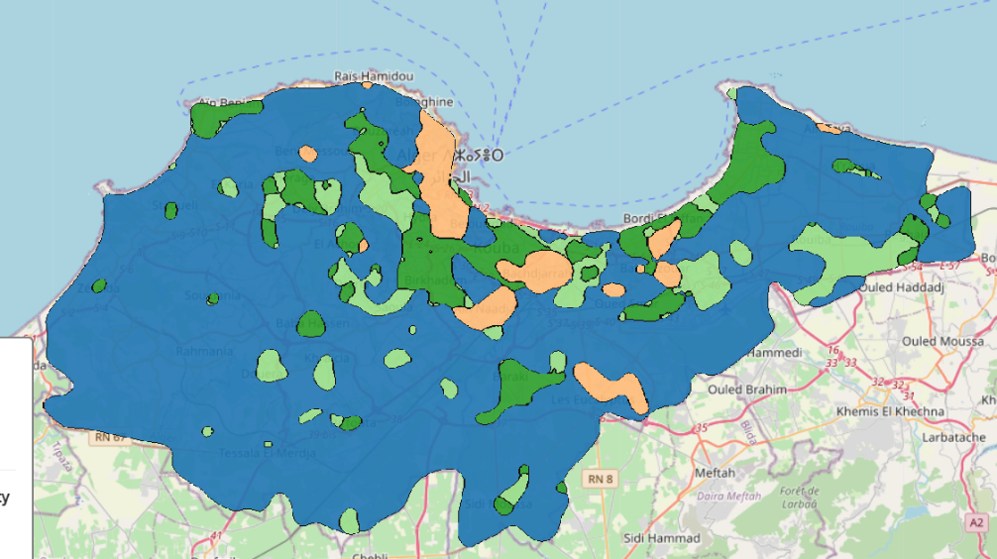

Figure 3: Final clustering result on the interactive map

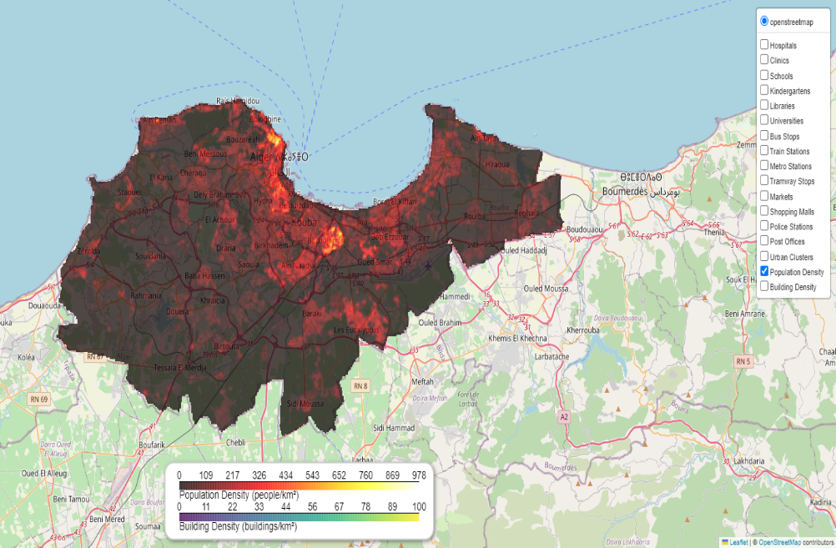

Figure 4: Example of final display (case: population)

3.4 Technical Constraints Encountered
3.4.1 Coordinate Reference System (CRS) Issues
The .tif raster files and the GeoJSON vector data were often in different projection systems (EPSG:3857 vs. EPSG:4326). This required consistent reprojection using Rasterio and QGIS.

3.4.2 Spatial Mask Reconstruction
HDBSCAN returns only valid points without geographic coordinates. It was therefore necessary to reconstruct a 2D boolean matrix from linear indices, then convert them into spatial references (row, column).

3.4.3 Cluster Number Stability (Elbow Method)
The "elbow" point is not always clearly visible. In some cases, it was necessary to rerun the tests several times or adjust curvature parameters manually to detect the elbow.

3.4.4 HTML Map Size
The final map, including all clusters, legends, popups, and layers, weighs several megabytes. This affects loading speed, especially on mobile browsers. Techniques such as lazy loading or tile-based splitting could be considered in a production version.

3.5 Results Analysis
Clusters revealed distinct urban profiles in Algiers:
Cluster | Description | Population Density (inhab./km²) | Building Density (buildings/km²)
Blue | Very low density / Non-urban areas | 9.88 | 21.68
Yellow | High population and building density | 39.31 | 249.35
Dark Green | Moderate density | 38.75 | 127.48
Light Green | Low population and building density | 35.43 | 62.30
Each class contains average statistics for both indicators, providing a valuable decision-support tool for urban planning, telecom infrastructure deployment, or development monitoring.
The approach is flexible and could be adapted to:
• The analysis of areas with weak network coverage
• The planned expansion of fiber-optic infrastructure
• The segmentation of commercial offers by region
• The anticipation of urban growth

3.6 Integration into a Web Platform
To highlight the geospatial processing and segmentation work carried out during this project, a web integration of the interactive map was planned. This phase, handled in parallel by a team member, aims to make the map accessible online through a simple, user-friendly interface usable by Djezzy's internal teams.
3.6.1 Integration Objective
The integration into a web platform is intended to transform the static HTML file generated by Folium into a remotely accessible application. The goal is to allow various users (engineers, decision-makers, project managers) to easily explore the segmentation results without needing to manipulate code or specialized GIS tools.
3.6.2 Proposed Architecture
The HTML map exported by Folium is embedded within a static web interface, developed using standard technologies: HTML, CSS, and JavaScript. This lightweight architecture offers:
• Immediate display in a browser (no heavy server required)
• Compatibility with Djezzy’s internal infrastructure (intranet)
• Smooth, responsive navigation, including on tablets and smartphones
The website features a main page containing the map and a navigation menu that allows users to enable or disable different layers: population density, building density, clusters, points of interest, etc.
3.6.3 User Interactions
The web version includes several interactive features:
• Dynamic filters (checkboxes) to show or hide specific layers
• Tooltips on hover to display cluster characteristics (population, density, etc.)
• A color legend dynamically updated based on the visible clusters
These elements are designed to make result interpretation intuitive and usable, even for non-specialists in geospatial data.

3.7 Conclusion
This chapter detailed the pipeline’s implementation. Combining open data, unsupervised clustering, and modern visualization, we extracted actionable insights for Algiers. Future improvements could include temporal data or socio-economic indicators.

Conclusion and Perspectives

Conclusion

The project presented in this report aimed to design an automated and intelligent geospatial analysis solution, applied to the city of Algiers, in partnership with the telecom operator Djezzy. By combining raster data (population, buildings) with unsupervised clustering techniques (HDBSCAN and MiniBatchKMeans), we developed a processing pipeline capable of identifying, grouping, and visualizing urban areas based on occupancy density.
The strength of this project lies in:
• The integration of open public datasets (GHSL, OSM)
• The use of powerful, modular open-source tools
• The production of a clear interactive map accessible via a web browser
• The full automation of the processing workflow, making the tool reusable for other cities or regions
This approach provides a valuable decision-support tool for Djezzy’s technical teams, enabling them to quickly locate critical areas, plan network interventions, and better understand the urban structure of the territory.

Perspectives

Several improvement and development opportunities can be considered based on this functional foundation:
• Integration of temporal data: to monitor the evolution of urban areas over time and anticipate future needs.
• Addition of socio-economic indicators: such as average income, network coverage rate, or the number of customer complaints per area, to enrich the analysis.
• Full deployment on a web or cloud server: with a secure, multi-user interface connected to Djezzy’s internal databases.
• Adaptation to other wilayas or contexts: thanks to the modularity of the pipeline, the solution can easily be extended to other cities or use cases (e.g., fiber coverage, urban planning).
• Integration of a real-time monitoring layer: to dynamically display network performance in relation to the detected clusters.

Bibliographic References
Geospatial Data Sources
- Copernicus Emergency Management Service. Global Human Settlement Layer (GHSL). https://human-settlement.emergency.copernicus.eu/ (Accessed in 2024).
- OpenStreetMap Foundation. OpenStreetMap – Free Collaborative Geospatial Database. https://www.openstreetmap.org (Accessed in 2024).
• GADM – Database of Global Administrative Areas – https://gadm.org/

Machine Learning Algorithms and Concepts
- Campello, R.J.G.B., Moulavi, D., & Sander, J. (2013). Density-Based Clustering Based on Hierarchical Density Estimates. In: Advances in Knowledge Discovery and Data Mining. Springer.
- Arthur, D., & Vassilvitskii, S. (2007). k-means++: The Advantages of Careful Seeding. In Proceedings of the 18th Annual ACM-SIAM Symposium on Discrete Algorithms.
- Scikit-learn developers. (2024). Scikit-learn: Machine Learning in Python – Version 1.4.2. https://scikit-learn.org
- McInnes, L., Healy, J., & Astels, S. (2017). HDBSCAN: Hierarchical Density-Based Spatial Clustering of Applications with Noise. Journal of Open Source Software, 2(11), 205. https://hdbscan.readthedocs.io

Python Environment & Libraries Used
- Van Rossum, G., & Drake, F.L. (2009). The Python Language Reference Manual. Python Software Foundation. Version used in the project: Python 3.10.11.
- Harris, C. R., Millman, K. J., et al. (2020). Array programming with NumPy. Nature, 585(7825), 357–362.
- McKinney, W. (2010). Data Structures for Statistical Computing in Python. In Proceedings of the 9th Python in Science Conference. (Used via Pandas 2.2.0).
- Rasterio developers. (2024). Rasterio: Geospatial raster I/O for Python programmers. https://rasterio.readthedocs.io
- Folium team. (2024). Folium: Python wrapper for Leaflet.js maps. https://python-visualization.github.io/folium/
- Branca project. (2024). Branca: Generate colormaps and legends for Folium. https://python-visualization.github.io/branca/
- Joblib developers. (2024). Joblib: Efficient processing for Python. Version 1.3.2. https://joblib.readthedocs.io

GIS and Mapping Technologies
- QGIS Development Team. (2024). QGIS: A Free and Open Source Geographic Information System. Version 3.34. https://qgis.org
- GDAL/OGR contributors. (2024). Geospatial Data Abstraction Library (GDAL). Version 3.6. https://gdal.org

Development Environment and Tools
- Microsoft. (2024). Visual Studio Code (VS Code) – Cross-platform Code Editor. Version used: 1.88.0. https://code.visualstudio.com
- GitHub Inc. (2024). GitHub – Version Control and Collaboration Platform. https://github.com
- Adobe Inc. (2023). Adobe Photoshop CC – Graphic Design Software. Version 24.0.

Annexes

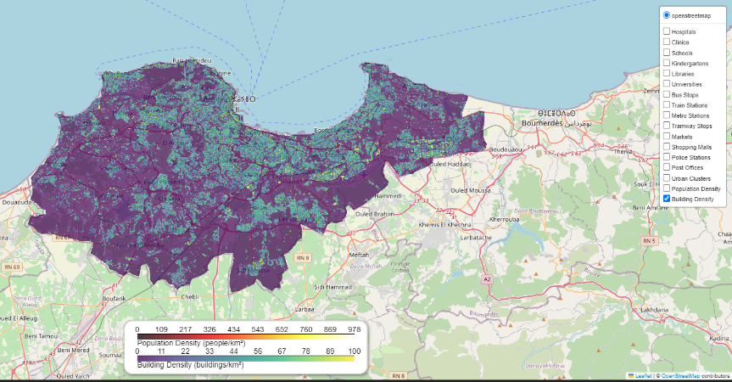

Figure: Example of final display (Case: Buildings)

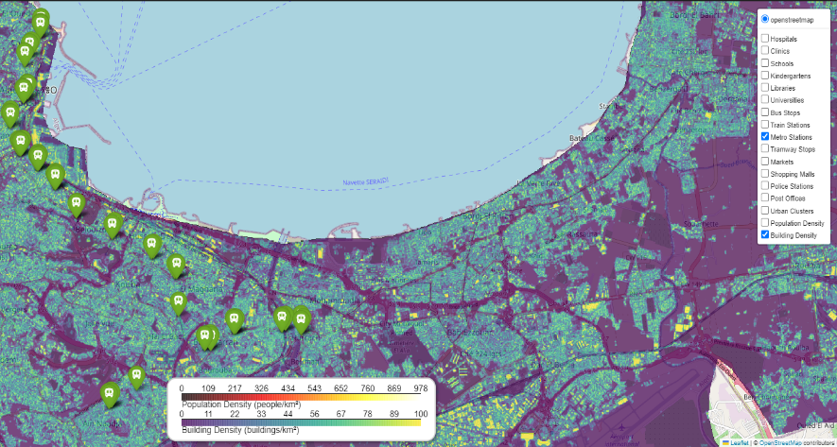

Figure: Example of final display (Case: Metro Stations)

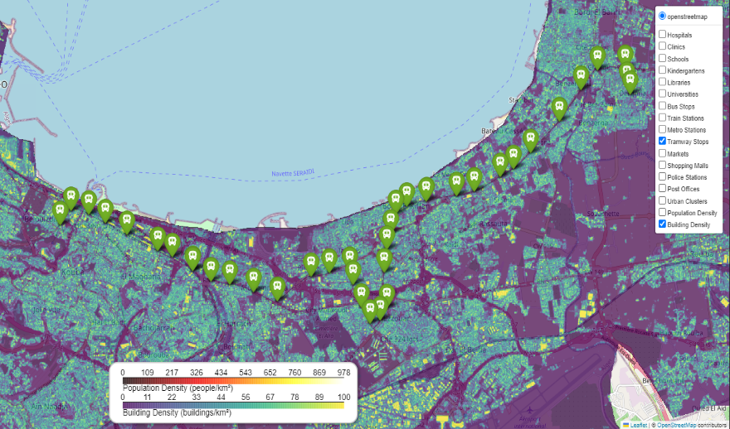

Figure: Example of final display (Case: Tramway Stations)

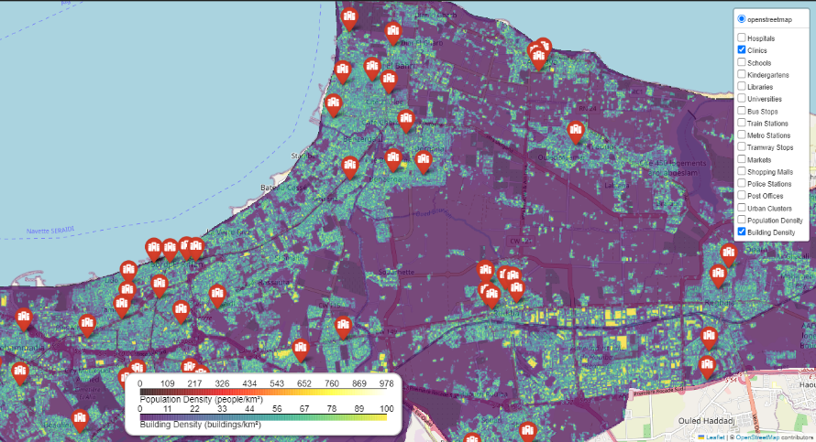

Figure: Example of final display (Case: Clinics)

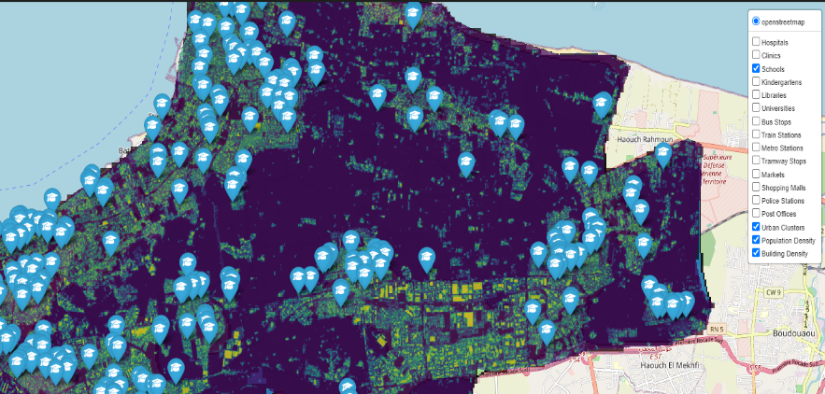

Figure: Example of final display (Case: Schools)

